**Conclusions and recommendations for Big Mountain resort**

This research is regarding some recommendations to appropriately increase the ticket price for Big Mountain resort and consequently improving revenue.

According to this analysis, it has been observed there are dominant top four features according to the figure 1.

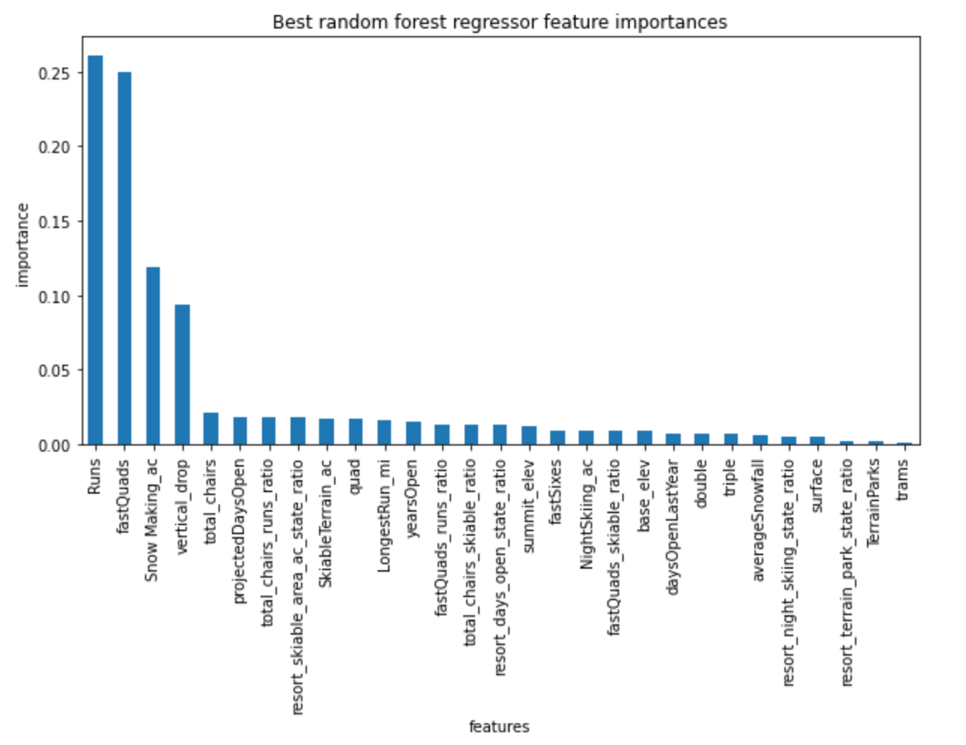

Figure 1-Important features

These are: count of the number of runs on the resort (Runs), the number of fast four person chairs (fastQuads), the total area covered by snow making machines (Snow Making_ac) and vertical change in elevation from the summit to the base in feet (Vertical_drop).

Based on the analysis, there are two graphs shown in the figure 2 related to impact of runs closed.

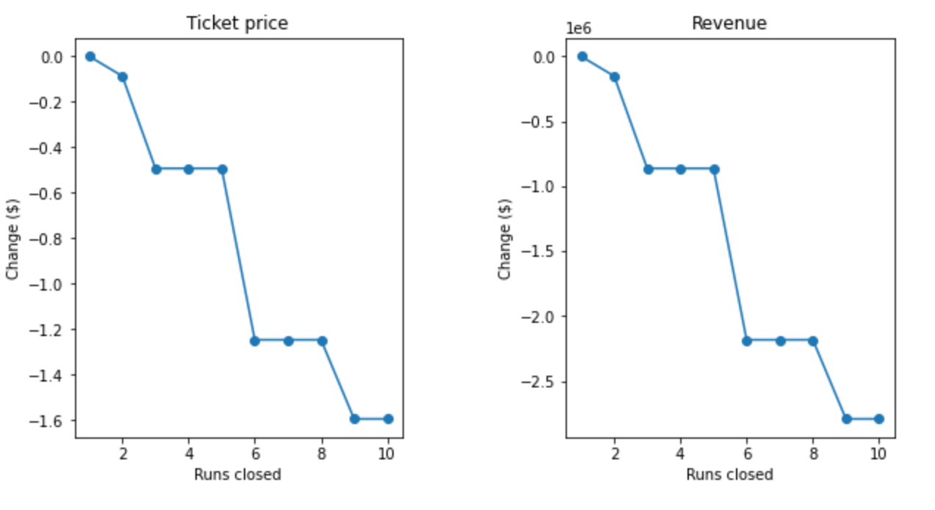

Figure 2-The impact of runs closed on ticket price and revenue

According to figure 2, closing one run doesn't have an impact on the ticket price and revenue. On the other hand; closing for two or three runs causes reduction in ticket price. In addition, closing for 6 runs will have large drop in ticket price. So, the reduction in ticket price can be managed based on this graph.

Furthermore, with respect to data modelling there are these recommendations:

**Approach 1:**

Adding run, increasing vertical drop and installation of additional chair lift support to increase the ticket price by $1.3 over the season. The revenue is estimated about $2282609.

**Approach 2:**

Assuming the condition of first approach and adding 2 acres of snow making can support to increase the ticket price by $1.3 over the season and the revenue is estimated about $2282609. Therefore, small increase of snow making area is not effective on the results.

**Approach 3:**

Increasing the longest run by 0.2 miles and adding 4 acres of snow making won’t have any impact on the ticket price.